**Assignment 1:**

Task 1:

1,

Install Jupyter notebook and run the first program and share the screenshot of the output

Output:

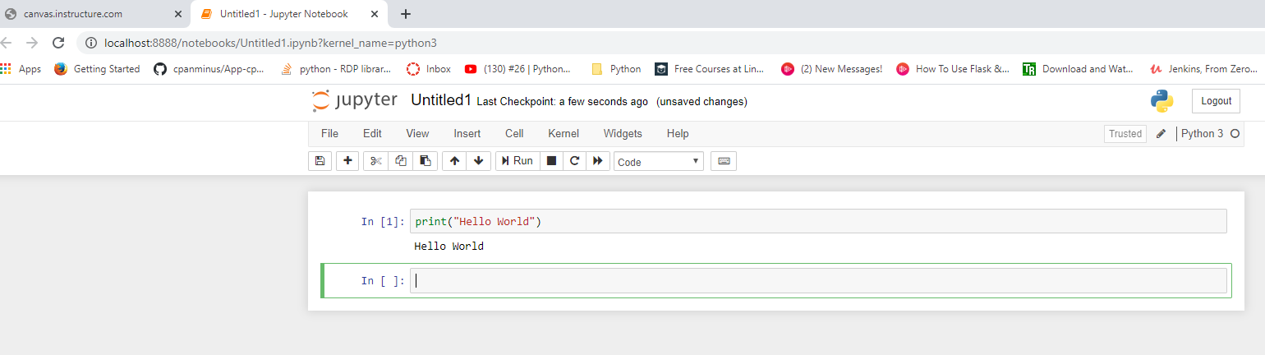

2.

Write a program which will find all such numbers which are divisible by 7 but are not a multiple of 5, between 2000 and 3200 (both included). The numbers obtained should be printed in a comma-separated sequence on a single line.

Code:

l=[]

for i in range(2000,3201):

    if i%7==0 and i%5!=0:

        l.append(str(i))

# print(l)

print(",".join(l))

Output:

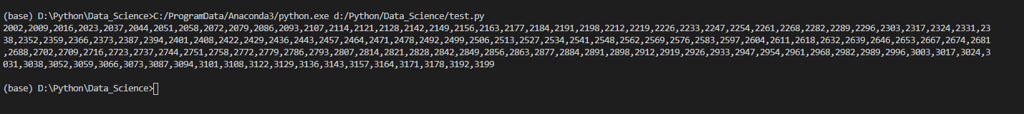

**3.**

Write a Python program to accept the user's first and last name and then getting them printed in the the reverse order with a space between first name and last name.

Code:

fname=input("Enter the First Name: ")

Lname=input("ENter the Last Name: ")

print(Lname," ",fname)

Output: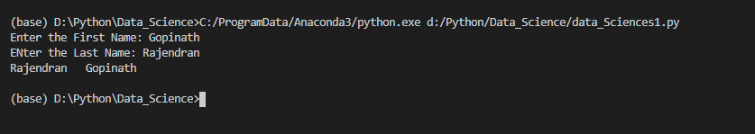

**4,**

Write a Python program to find the volume of a sphere with diameter 12 cm.

Formula: V=4/3 * π * r 3

Code:

pi=3.14

r = float(12/2)

V = (float(4/3)*(pi)*(r)**3)

print(V)

Output:

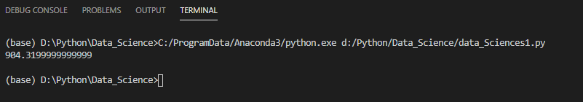

**Task 2**:

1, Write a program which accepts a sequence of comma-separated numbers from console and generate a list.

Code:

seq=input("Enter the Comma seprated numbers: ")

list=seq.split(",")

print(list)

Output:



2, Create the below pattern using nested for loop in Python.

3, Write a Python program to reverse a word after accepting the input from the user.

Code:

input=input("Enter the string to reverse it: ")

print("The Orginal String",input)

input=input[::-1]

print("The Oraginal String",input)

Output:

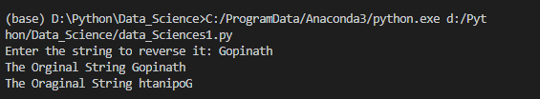

4, Write a Python Program to print the given string in the format specified in the sample output.

**Code:**

print( """WE, THE PEOPLE OF INDIA,\n \t having solemnly resolved to constitute India into a SOVEREIGN,! \n \t\t SOCIALIST, SECULAR, DEMOCRATIC REPUBLIC \n\t\t and to secure to all its citizens""")

**Output:**

